Gary Andreas 2311533004 Informatika

**Tugas Pekan 6**

1. 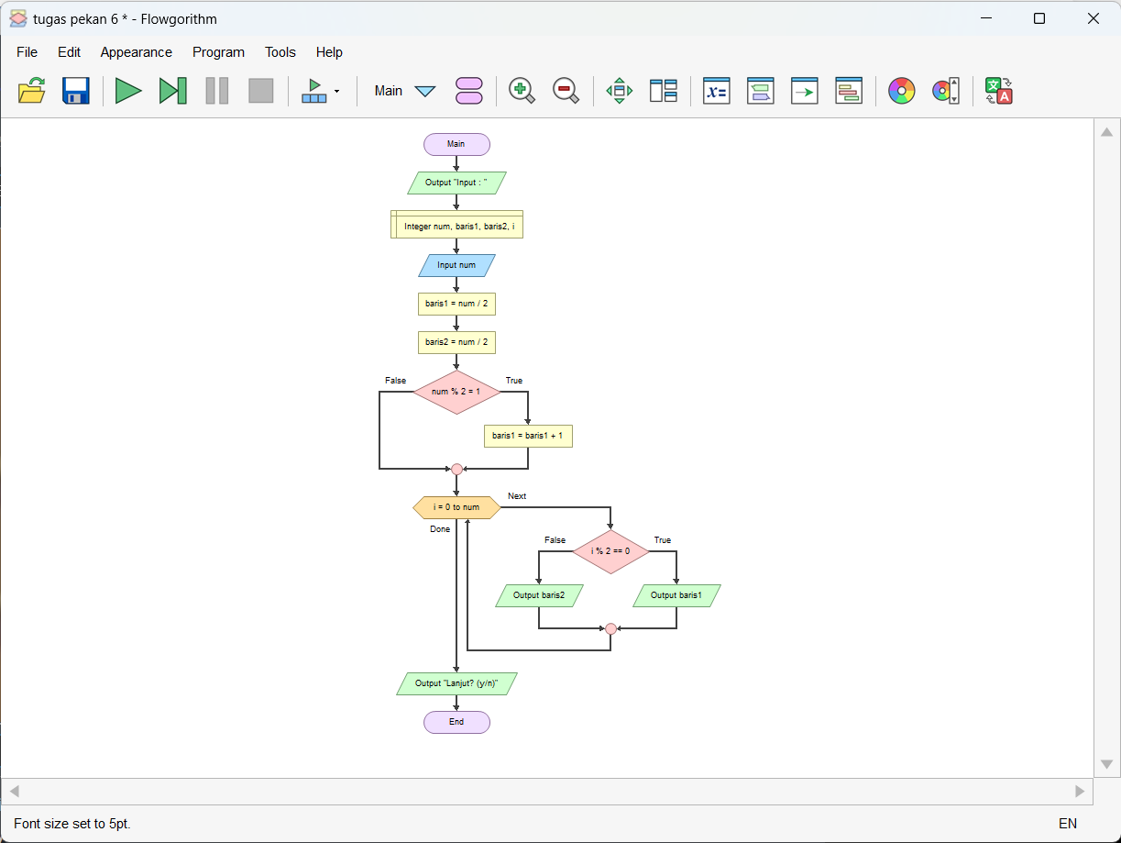Flowchart
2. 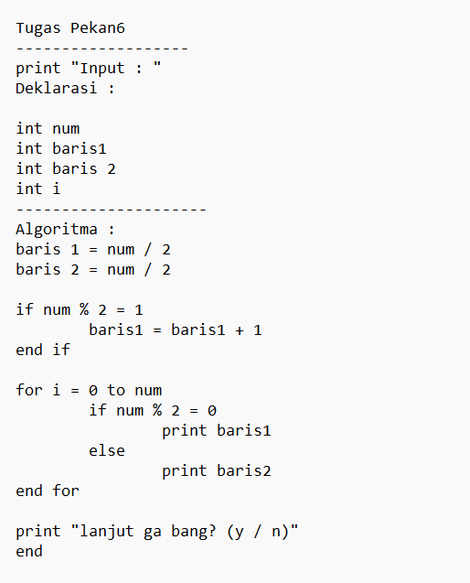Pseudocode